AMRUTVAHINI COLLEGE OF ENGINEERING, SANGAMNER

DEPARTMENT OF COMPUTER ENGINEERING

2023-2024

LP-VI Mini Project report (IP)

# on

‘Object Segmentation and Detection of Moving Objects with PixelLib’



# BE Computer Engineering BY

Mr. Gaurav Bhima Chaudhari(4117) Mr. Harsh Sunil Chhajed(4118) **Guided by** – Dr. R. G. Tambe

* **Title:** Object Segmentation and Detection of Moving Objects with PixelLib.
* **Abstract:**

This report investigates the capabilities of PixelLib, a library designed for semantic and instance segmentation of objects in images and videos. PixelLib facilitates the segmentation and detection of moving objects in videos by leveraging deep learning models. The report explores the methodology, setup, implementation details, code snippets, and presents the results of object segmentation and detection using PixelLib.

* **Introduction:**

Object segmentation and detection are fundamental tasks in computer vision, enabling various applications such as surveillance, autonomous vehicles, and activity recognition. PixelLib offers a comprehensive solution for segmenting and detecting moving objects in videos, making it accessible to developers with minimal effort. This report aims to provide an overview of PixelLib's capabilities and demonstrate its usage for object segmentation and detection of moving objects.

* **Methodology:**

PixelLib utilizes deep learning models to perform semantic and instance segmentation tasks on images and videos. The library supports pre-trained models such as Mask R-CNN and Deeplabv3+ for accurate and efficient segmentation. The methodology involves loading a pre-trained model, providing input videos for segmentation and detection, and executing the process to identify and track moving objects.

* **Setup:**

To utilize PixelLib for object segmentation and detection, the following libraries need to be installed:

opencv-python, scikit-image, pillow, matplotlib, imgaug, labelme2coco, imantics, Cython, pyQt5, fvcore, iopath, omegaconf, cloudpickle, termcolor, yacs, tabulate, tqdm, future, pydot, dataclasses, hydra-core, black.

These dependencies can be installed using the provided setup code.

* **Setup Code and Requirements:**

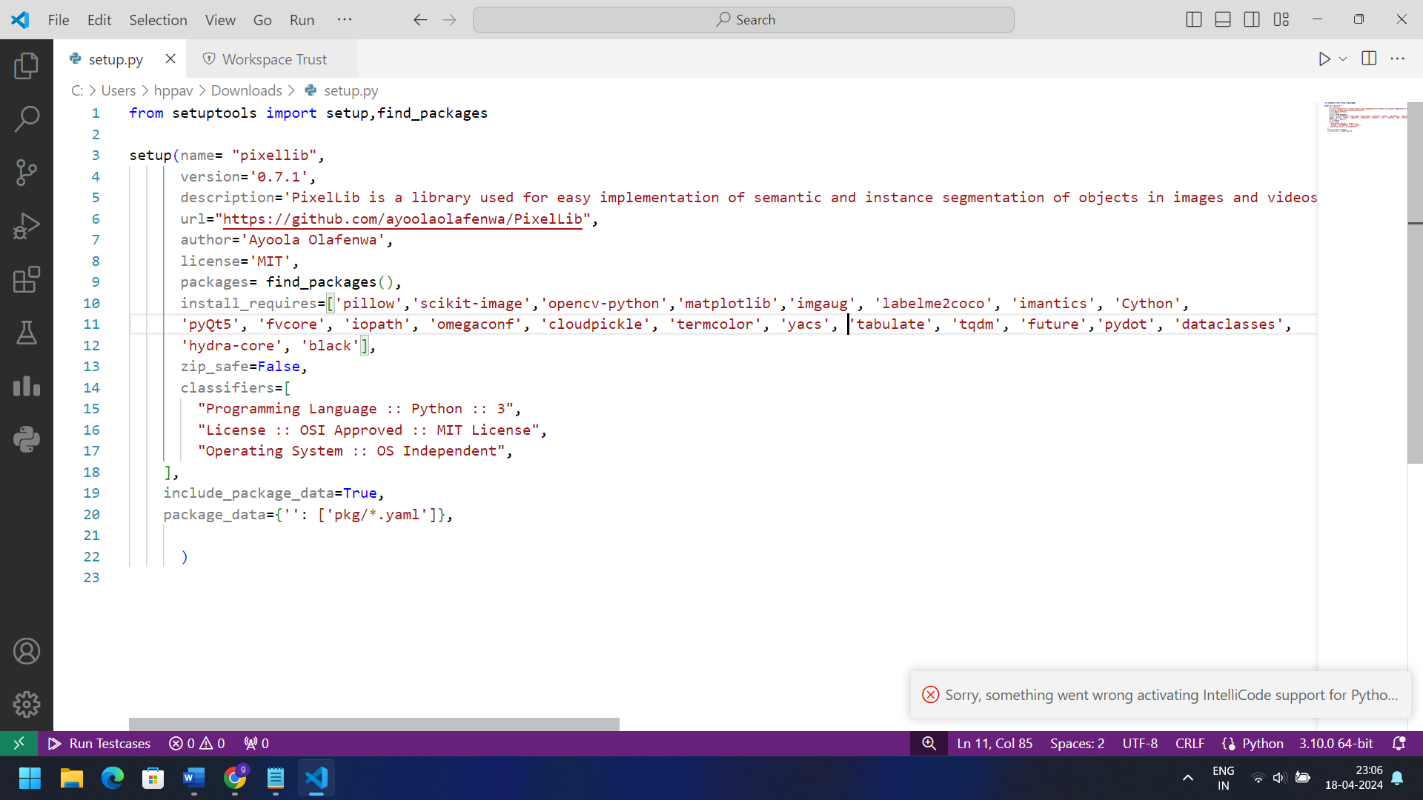

* **Implementation and code:**

We implemented object segmentation and detection of moving objects using PixelLib by following these steps:

* Initialize the instance segmentation model.
* Load a pre-trained Mask R-CNN model.
* Provide input videos for segmentation and detection.
* Execute the segmentation and detection process to identify and track moving objects.

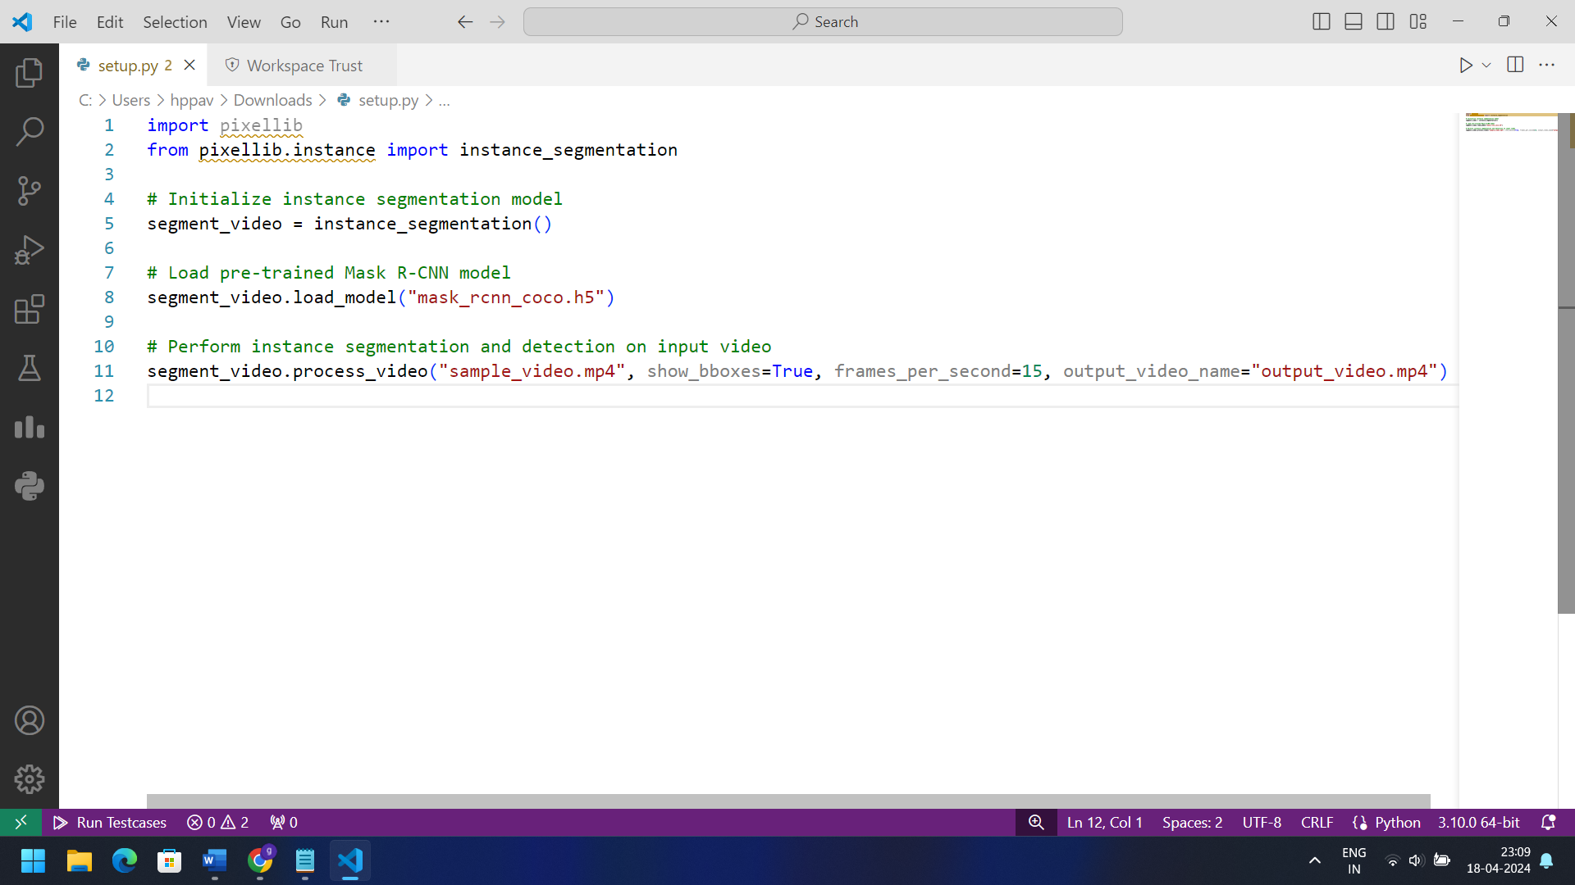

* **Results:**
* Object Segmentation and Detection with PixelLib

Using the provided implementation code, we performed instance segmentation and detection of moving objects in the input video "sample_video.mp4" using the pre-trained Mask R-CNN model. The output video "output_video.mp4" demonstrates the segmented objects with bounding boxes overlaid, effectively detecting and tracking moving objects.

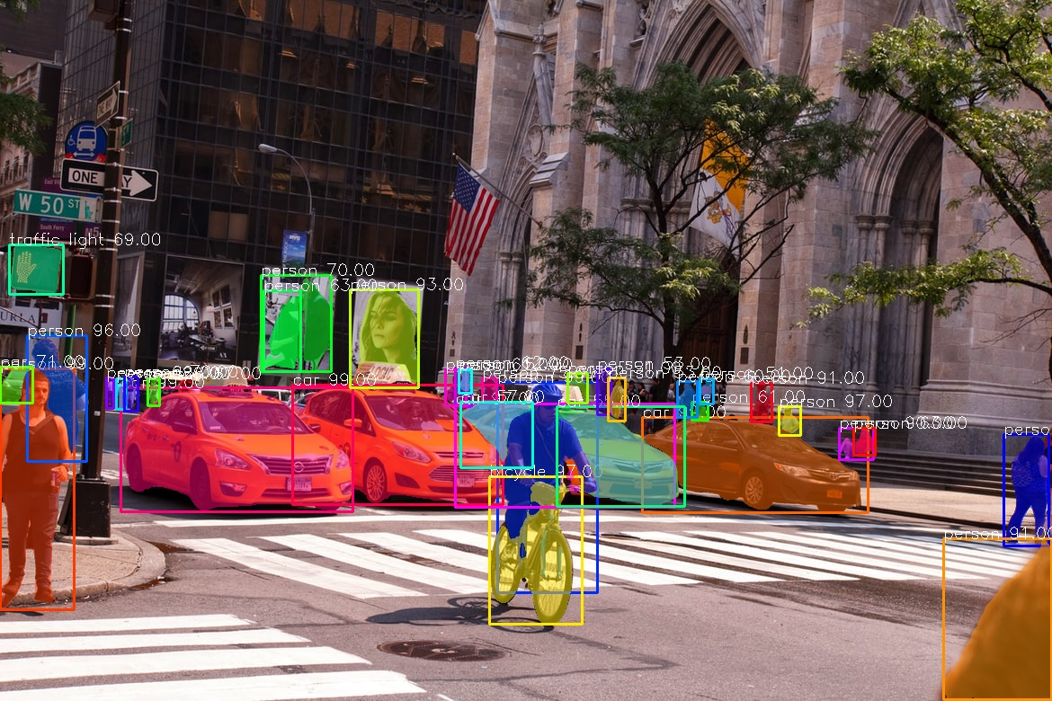

Image Segmentation with Pytorch Using PointRend

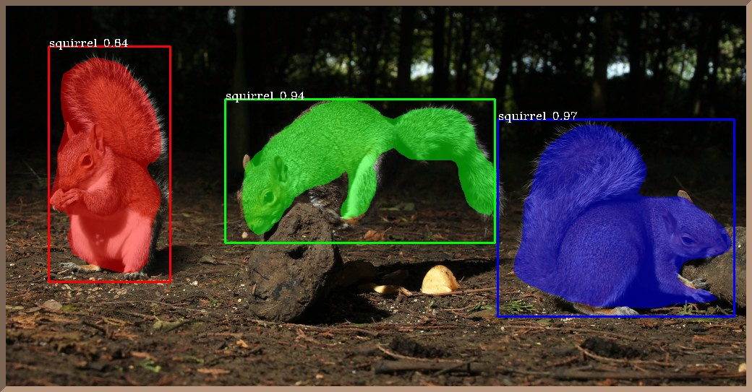

This is a result from a model trained with PixelLib.

* **Conclusion:**

PixelLib offers a powerful solution for object segmentation and detection of moving objects in videos, enabling developers to build advanced computer vision applications with ease. By leveraging pre-trained deep learning models and a user-friendly API, PixelLib streamlines the process of segmentation and detection, making it accessible to a wider range of developers. With PixelLib, object segmentation and detection become more efficient and accurate, paving the way for innovative applications in surveillance, traffic monitoring, and beyond.